DEVIKA B
Roll No:22

LAB CYCLE -6 :

MongoDB Aggregation Operations

Use the following sales collection
db.sales.insertMany([
{ _id: 1, item: "Americanos", price: 5, size: "Short", quantity: 22, date: ISODate("2022-01-15T08:00:00Z") },
{ _id: 2, item: "Cappuccino", price: 6, size: "Short", quantity: 12, date: ISODate("2022-01-16T09:00:00Z") },
{ _id: 3, item: "Lattes", price: 15, size: "Grande", quantity: 25, date: ISODate("2022-01-16T09:05:00Z") },
{ _id: 4, item: "Mochas", price: 25, size: "Tall", quantity: 11, date: ISODate("2022-02-17T08:00:00Z") },
{ _id: 5, item: "Americanos", price: 10, size: "Grande", quantity: 12, date: ISODate("2022-02-18T21:06:00Z") },
{ _id: 6, item: "Cappuccino", price: 7, size: "Tall", quantity: 20, date: ISODate("2022-02-20T10:07:00Z") },
{ _id: 7, item: "Lattes", price: 25, size: "Tall", quantity: 30, date: ISODate("2022-02-21T10:08:00Z") },
{ _id: 8, item: "Americanos", price: 10, size: "Grande", quantity: 21, date: ISODate("2022-02-22T14:09:00Z") },
{ _id: 9, item: "Cappuccino", price: 10, size: "Grande", quantity: 17, date: ISODate("2022-02-23T14:09:00Z") },
{ _id: 10, item: "Americanos", price: 8, size: "Tall", quantity: 15, date: ISODate("2022-02-25T14:09:00Z") }
]);

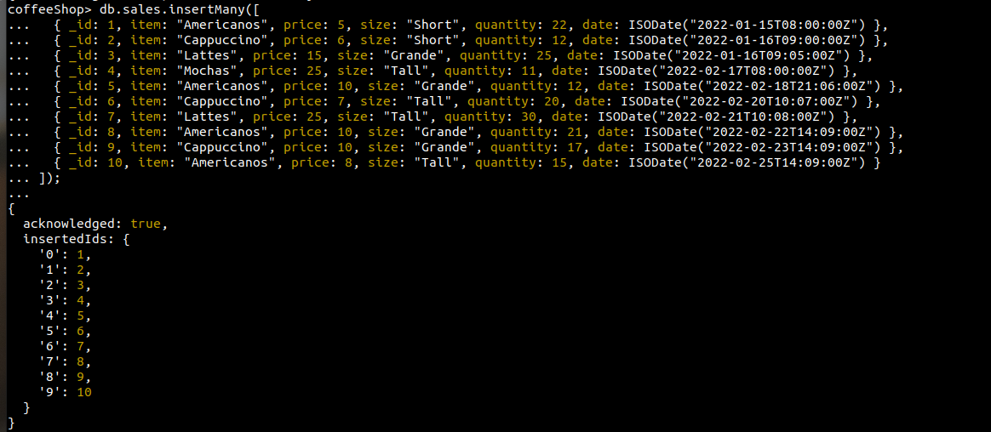
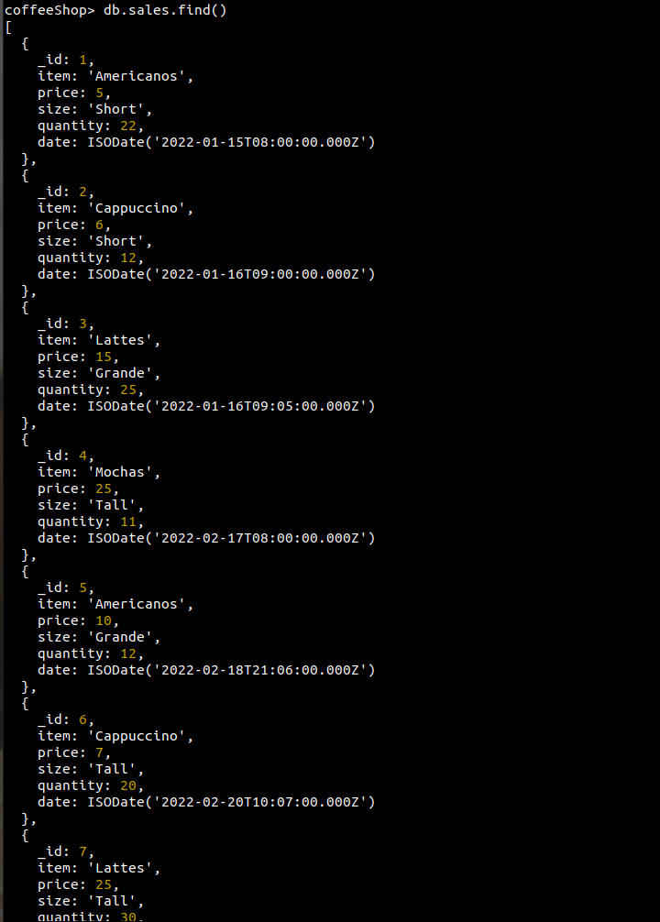

1. Group documents by the item field and calculate the average amount for each group.
db.sales.aggregate([
{
$group: {
_id: '$item',
averageAmount: { $avg: { $multiply: ['$quantity', '$price'] } },
},
},
{ $sort: { averageAmount: 1 } },
]);
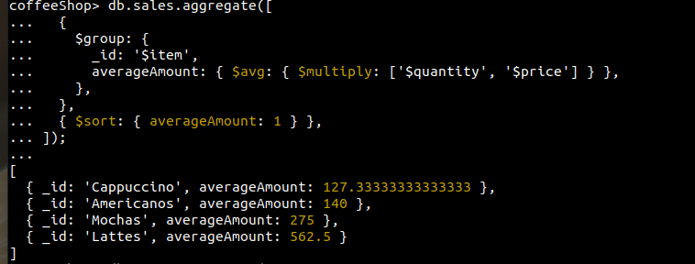

2. Calculate the average amount per group and return groups with average amount greater than 150.
db.sales.aggregate([
{
$group: {
_id: '$item',
averageAmount: { $avg: { $multiply: ['$quantity', '$price'] } },
},
},
{ $match: { averageAmount: { $gt: 150 } } },
{ $sort: { averageAmount: 1 } },
]);

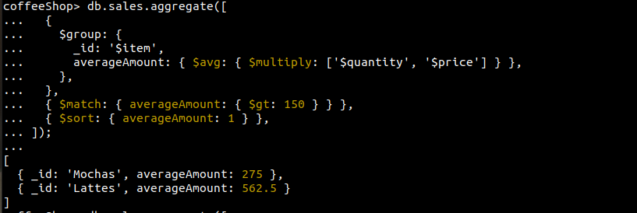

3. Return the number of items (documents) in the sales collection.
db.sales.aggregate([
{ $count: 'itemCount' }
]);

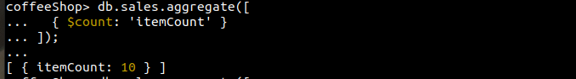

4. Calculate the number of documents per item and return only items with a count greater than 2.

db.sales.aggregate([
{
$group: {
_id: '$item',
itemCount: { $sum: 1 },
},
},
{
$match: { itemCount: { $gt: 2 } },
},
]);

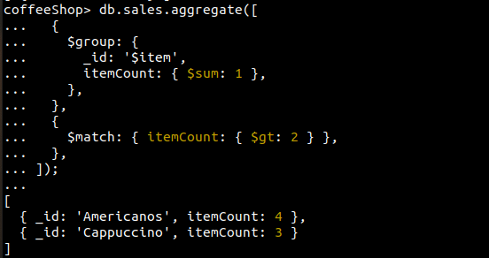

5. Calculate the total quantity of coffee sales in the sales collection.
db.sales.aggregate([
{
$group: {
_id: null,
totalQty: { $sum: '$quantity' },
},
},
{ $project: { _id: 0 } },
]);

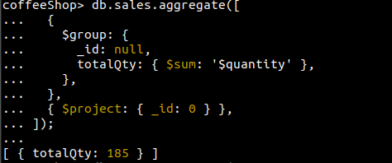

6. Calculate the sum of quantity grouped by items.
db.sales.aggregate([
{
$group: {
_id: '$item',
totalQty: { $sum: '$quantity' },
},
},
]);
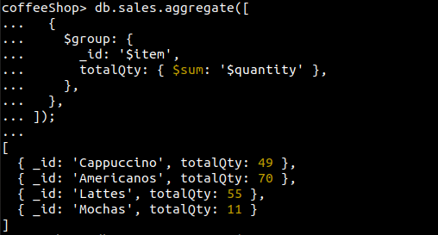

7. Return the total quantity of each item and sort the result by totalQty in descending order.

db.sales.aggregate([
{
$group: {
_id: '$item',
totalQty: { $sum: '$quantity' },
},
},
{ $sort: { totalQty: -1 } },
]);

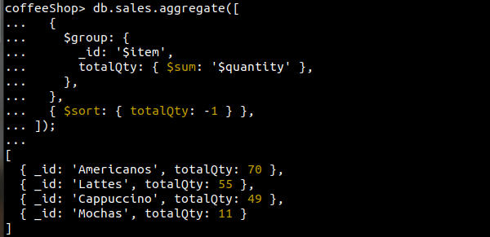

8. Find the maximum quantity from all the sales documents.

db.sales.aggregate([
{
$group: {
_id: null,
maxQty: { $max: '$quantity' },
},
},
{
$project: {
_id: 0,
},
},
]);
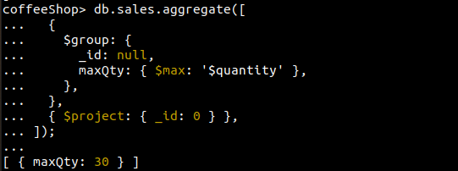

9. Group by item and return the maximum quantity per group.
db.sales.aggregate([
{
$group: {
_id: '$item',
maxQty: { $max: '$quantity' },
},
},
]);
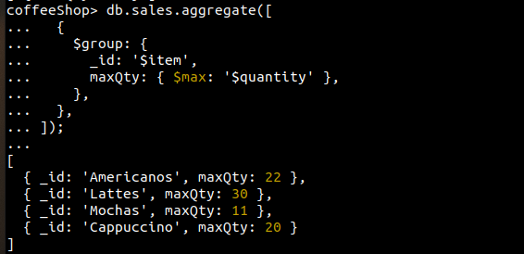

10. Group by item and return the maximum total amount (price * quantity) for each item.

db.sales.aggregate([
{
$group: {
_id: '$item',
maxQty: { $max: { $multiply: ['$quantity', '$price'] } },
},
},
]);
